TECHNICAL REPORT ON STUDENT INDUSTRIAL WORK EXPERIENCE SCHEME (SIWES)

AT

YAKK BUILT VENTURES ARCHITECTS AND BUILDERS,
IKOT-EKEPNE, AKWA IBOM STATE

FROM: 6TH OCTOBER, 2023
TO: 29TH JANUARY, 2024

BY

EKEMINI UDUAK ANNANG
(SE/ARC/ND/22/053)

DEPARTMENT OF ARCHITECTURAL TECHNOLOGY, FEDERAL POLYTECHNIC MUBI, IN PARTIAL FULFILLMENT OF THE REQUIREMENT FOR THE AWARD OF NATIONAL DIPLOMA (ND) IN ARCHITECTURAL TECHNOLOGY

MARCH, 2024

DECLARATION
This is to declare that I, EKEMINI UDUAK ANNANG with registration number SE/ARC/ND/22/053 undertook my four months SIWES at YAKK BUILT VENTURES ARCHITECTS AND BUILDERS, IKOT-EKEPNE, AKWA IBOM STATE and have acquired all the experience compiled in this report in the course of my SIWES.

……………………………….. ……………………………
EKEMINI UDUAK ANNANG Sign/Date

CERTIFICATION
This is to certify that this report compiled by EKEMINI UDUAK ANNANG (SE/ARC/ND/22/053) meets the regulations of governing the award of National Diploma (ND) of the Federal Polytechnic Mubi, and is approved by:

………………………………. …………………………
Name of Supervisor Date
Departmental Supervisor

………………………………. …………………………
Arc. Dangana T. Halla Date
Departmental SIWES Coordinator

…………………………………. …………………………
Arc. Hussaini Haruna Date
Head of Department
DEDICATION
I dedicate this technical report to my parents, my sisters and colleagues and to all those that supported me throughout me industrial training.

ACKNOWLEDGEMENTS
First of all, my sincere appreciation goes to Almighty God and salutation to my prophet.
I wish to thank all staff of Architectural Technology department in Federal Polytechnic, Mubi.
My appreciation goes to my beloved parent for the motivation, prayers and financial support towards my SIWES exercise.
My special thanks go to my beloved brothers and sisters for all their care and support throughout my industrial training.
I want to also thank my colleagues and others; I really appreciate your efforts.

TABLE OF CONTENTS
TITLE PAGE………………………………………………………………… i
DECLARATION…………………………………………………………….. ii
CERTIFICATION………………………………...………….………………. iii
DEDICATION………….………………………..………….……………….. iv
ACKNOWLEDGEMENT……………………………………….……………v
TABLE OF CONTENTS…………………………………..…….……………vi
ABSTRACT……………………………………………………….…………. viii
CHAPTER ONE
1.0 Introduction……………………………………………………………….1
1.1 Aims and Objectives of SIWES………………………………………….. 1
1.2 Brief history of SIWES……………………………………………………2
1.3 Significance of SIWES………………………………………..…..……… 3
CHAPTER TWO
  - Brief History of Organization………………………..……........................ 4
2.2 Organogram……..………………………………………..……................. 4
CHAPTER THREE
3.0 Description of work experience……..………………………………….5
3.1 Setting out……..………………………………………..……............... 5
3.2 Site clearance…..………………………………………..……............. 5
3.3 Excavation of foundation……..……………………………………….. 5
3.4 Tiles Fixing………….…..…………………………………………….. 8
3.5 Working Drawing on site ……………………………………………... 10
CHAPTER FOUR
4.0 Summary, Recommendation and Conclusion…………………………. 14

4.1 Problems observed during my program……………………………….. 14
4.2 Summary……..…………………………………………………………14
4.3 Conclusion……..……………………………………………………….15
4.4 Recommendations……..………………………………………………. 15
Reference. ………………………………………..……................................... 16

ABSTRACT
The report summarises the result of work done during my SIWES experience, the technical report consists of four chapters, which comprises of introduction, history and criteria’s of SIWES in chapter one followed by their aims and objectives, historical background, organizational structure of the organization in chapter two, while chapter three consist of the work actually carried out during the SIWES programme and lastly chapter four consist of the summary, conclusions and recommendation.

CHAPTER ONE
1.0 INTRODUCTION
SIWES meaning “Student Industrial Work Experience Scheme” is a skill training designed to expose and prepare student in institution of higher for industrial working situation they may likely meet after graduation. The scheme is meant to train student on the method of work and the experience needed in handling the equipment and machines may not to be available in their institution. The scheme is financed by the Federal Government and operators through Industrial Training Fund (ITF), Ogwo, (2001) and operates with National University Commission (NUC), National Board of Technical Education (NABTEC), and National Commission for College of Education (NCCE) and industries. However, SIWES also expose the student to many practical works which the institution did not treat in details without plastering what the institution taught theoretically into practical. A point from academic obtained. SIWES assist the student to understand the nature of his/her work in future.

1.1 Aim of SIWES
The aim of this Student Industrial Work Experience Scheme (SIWES) is to expose the students to work experience and practicals.

1.2 Objectives of SIWES
- It helps the students to gain work experience during the Student Industrial Work Experience Scheme (SIWES).
- To identify proper work experience on Architectural designs and working drawing during Student Industrial Work Experience Scheme (SIWES).
- To study and adopt Architectural design during the Student Industrial Work Experience Scheme (SIWES) etc.

1.3 Brief history of SIWES and ITF in Nigeria
It was said by Dr. Azikiwe Nnamdi, the one president of Nigeria that the practice of work but they all have the same goal that they all want to achieve in countries like china. They established within the premises of institution to provide real life situation, lack of practical skill of locally trained engineers and technologies. the chine way and condition of SIWES is that all institution must give student real life working experience in industrial works. Lecturers are involved in the industrial activities rendering constant services. So, all these countries have their own way of conducting the scheme but all lye on the same goal. And in Nigeria, the history of SIWES can be traced by the history of IITF which is the backbone of SIWES. ITF was established in 1974 under degree of 47 of 1971 (Edward, 2003). It was a body established by the Federal Government of Nigeria and was given responsibility of training indigenous Nigerians. The establishment of the body became necessary due to high demand of Nigeria to take up the vacant positions created in various sector of the economy after the colonial masters have departed. Therefore, the Federal Government discovered that it is easier to train students that are skilled in school to be trained and meet up with gaps in the Nigerian economy and a scheme was established to care for such training and it was named Student Industrial Work Experience Scheme (SIWES). In 1973, the national board of technical education (NBTE) made it compulsory for all the polytechnic students, be it federal or state (Francis, 2012).

1.3 Significance of SIWES to students
Principles taught in the classroom are vein forced given concrete applications on the industrial assignment and students is able to see the relevance of their students which increase their motivation. It helps in given students the knowledge on the types of work to do after his/her graduation. SIWES given students opportunity for a change of environment as they move their institution to the place of attachment which changes the routine types of environment to a word of work. It helps in connecting the institution and the industrial their relationship the introduction of SIWES.

CHAPTER TWO
2.1 BRIEF HISTORY OF YAKKBUILT VENTURES
MAIN BRANCH:
No.36 Sanni Ogun Road, Ikot-Ekpene, Akwa Ibom State
DATE OF ESTABLISHMENT
Yakkbuilt venture is a non-governmental organization established at No.36 Sanni Ogun Road, Ikot-Ekpene, Akwa Ibom State on 15th September, 2010. And latter had another branch on 15th of November, 2022 which is located at No. 6 Garden City Uyo road, Ikot-Ekpene, Akwa Ibom State (Chudley, 2005).
2.2 ORGANIZATIONAL CHART
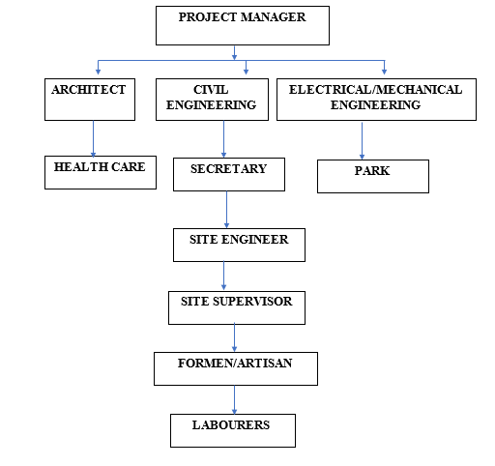

Figure 2.1: Organogram

CHAPTER THREE
3.0 DESCRIPTION OF WORK EXPERIENCE
3.1 SETTING OUT
345 method are used for the setting out, as observed after 90 from all angles using the pages ropes string and also from the plan.
Setting out is done with high degree of accuracy or else the building will not last as the engineer answered to my question “why are some calculations made during setting out”.
Procedure for the builder’s square method of the setting out:
- After site clearance material to be used were made available at the site.
- Proper site measurement was taken and all angles of the site were noted.
- Lines and blocks to be used were made available.
- Builder’s square was used to align the blocks and a line was used to extend the alignment to another angle of the site as specified in the floor plan, this was done continuously.
- The same method was applied to obtain all the angles of the building, by using this procedure demarcation, foundation boundary was made which brings about the starting point of excavation.
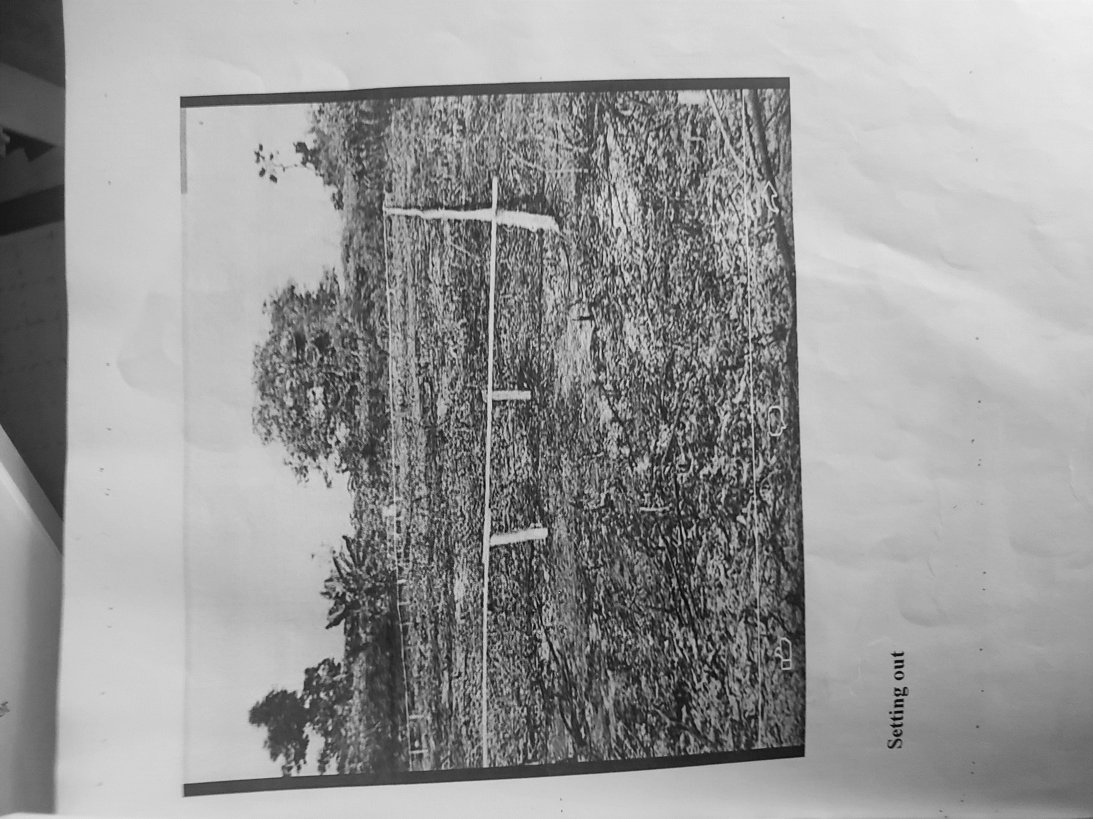
Plate 3.1: Setting out using profile board
Source: Author’s work, 2023

3.2 SITE CLEARANCE
Before the excavation of the proposed foundation commences, we cleared the site. So therefore, site clearance is the removal of all accumulated waste from an area to ensure that it is free from any environmental hazard, obstacle or unsightly mess.
3.3 EXCAVATION OF FOUNDATION TRENCH AND COLUMN BASE
Excavation can be defined as the process of digging a soil surface or trench for foundation lay into trench.
It is also the process of removing top soil for foundation trenches. Excavation work is an important part of building operation that commences immediately after setting out the width of excavation for foundation trenches is marked out on the profile and then transferred to the ground. Excavation must be carried out carefully to ensure safety of workers.
Excavation can be done using two methods mechanical and manual. In small construction we normally use manual method while in large construction we use mechanical e.g. like road construction.
Excavation work were carried out manually where unskilled labourer where involved with digger, shovels, head pan and wheel barrow. The following factors must be considered when carrying out any excavation work.
- Nature of the soil
- The width and depth of foundation
- Climatic condition at the time of excavation
- The water level of the soil
- The period excavation work is expected to be left open.
- The effect of excavation on existing adjacent structure.
As the engineer and the former goes to set basket, I was keeping an eye on how the beams were set. When digging the basket some places were 1.2 by 1.2 while some other places were 1.4 by 1.4 because of the type of soil on the site. When putting the basket in a poor soil, cement and sharp sand is mixed out before putting the basket to avoid rusting.
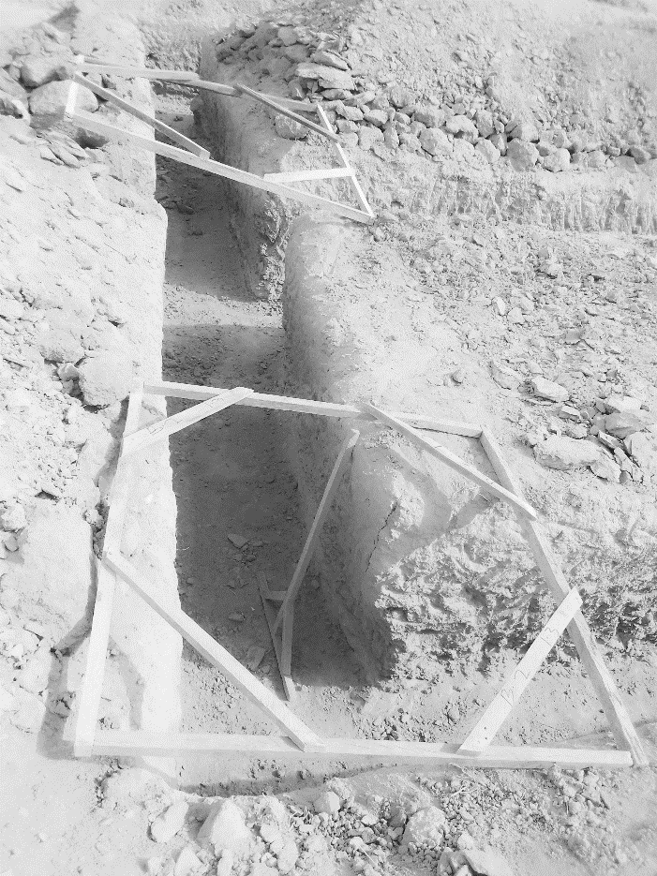
Plate 3.2: Excavation
Source: Author’s work, 2023
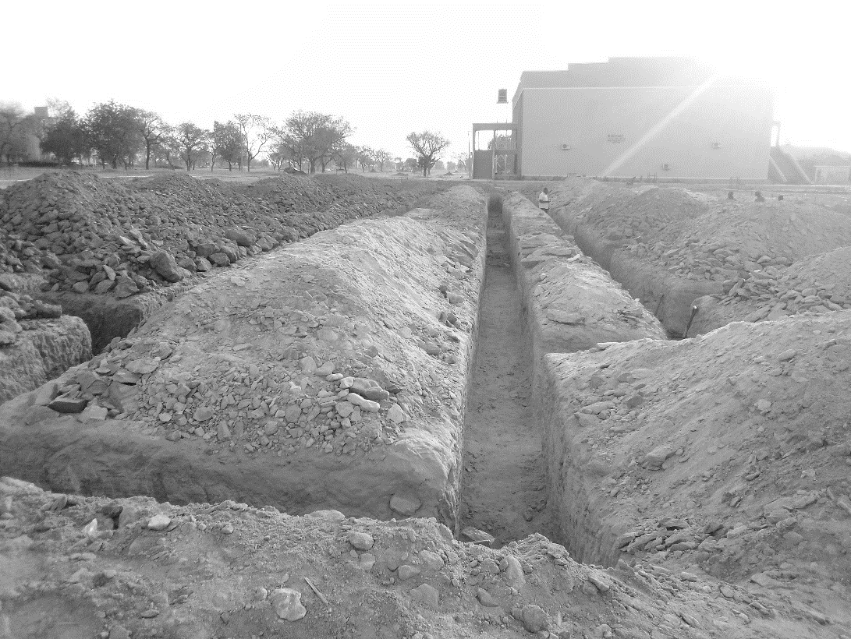

Plate 3.3: Excavation
Source: Author’s work, 2023

3.4 TILES FIXING
Before fixing the tiles, we laid them out in the desired pattern and mad sure that they gave an acceptable blend of shade, colour & design. Also, we made sure that the tiles were acceptable to our satisfaction.
Procedure:
- Safety First: Safety gloves and safety glasses were put on to protect against potential debris during the preparation process.
- Removal of Existing Flooring: which included vinyl, was carefully removed using a mallet, hammer, and utility knife. Care was taken not to damage the subfloor underneath.
- Floor level Inspection: The subfloor was closely examined for damage, unevenness, or protruding nails or screws. Ensured that the subfloor was structurally sound and free from rot or water damage. Damaged sections were replaced or repaired.
- Floor Levelling: A level was used to check for uneven areas on the subfloor. Uneven spots were marked with chalk lines. Low spots were filled with a self-levelling compound and patched according to the manufacturer's instructions.
- Baseboard and Trim Removal: Baseboards and trim were removed from the walls to facilitate a clean tile-to-wall transition.
- Tile Layout Planning: The layout of the tiles was planned meticulously, with careful measurements and a predetermined starting point. A carpenter's square and chalk lines were used to create guidelines for tile placement.
- Thin-Set Mortar Mixing and Application: Thin-set mortar was prepared as per the manufacturer's instructions. A notched trowel was used to apply a thin, even layer of mortar onto the subfloor or backer board.
- Tile Installation: Tiles were laid, commencing from the predetermined starting point, while adhering to the layout plan and guidelines. Each tile was firmly pressed into the mortar, ensuring consistent spacing using tile spacers.
- Mortar Setting: The mortar was allowed to set and cure for the duration specified by the manufacturer (typically 24 hours).
- Grout Application: Once the mortar had dried, grout was applied between the tiles using a rubber float. Excess grout was wiped away using a damp sponge.
- Baseboard and Trim Reinstallation: After the grout had dried, baseboards and trim were reinstalled to cover the tile edges.
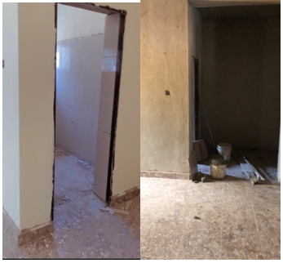
Plate 3.4: Tiled surface of the floor
Source: Author’s work, 2023

3.5 WORKING DRAWING ON SITE
During my SIWES, I was able to design a floor plan, roof plan, front elevation, back elevation right elevation, and left elevation. Fine attached.
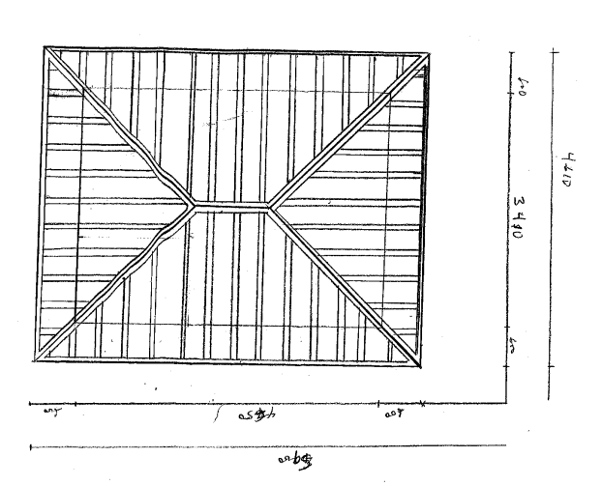
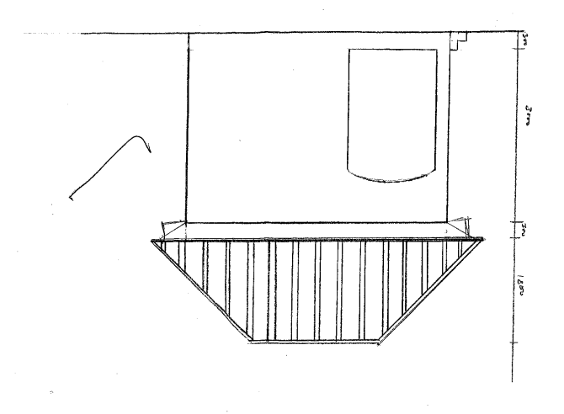
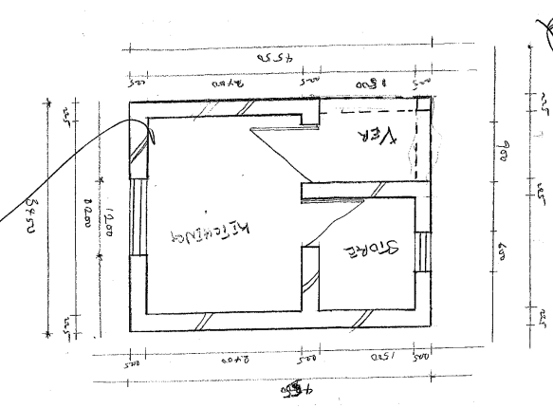
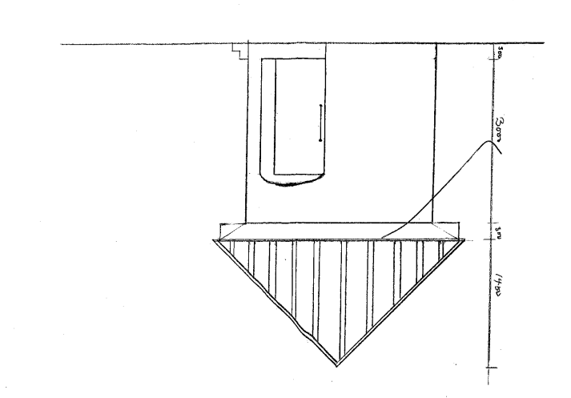

CHAPTER FOUR
4.0 SUMMARY, RECOMMENDATION AND CONCLUTION

4.1 PROBLEMS OBSERVED DURING MY PROGRAM
- The time frame set for the program is too short as some of the aspects of the program where not completed.
- Lack of Financial support from the company to aid transportation to and from training.
- Attentions are not given to the IT students by the workers it is learn if you want to learn or ask if you want to know.

4.2 SUMMARY
One would state that the discipline is the training of the mind and body towards effective performance. The Students Industrial Work Experience Scheme (SIWES) is more or less achieving this fit. As it further builds on the theoretical classrooms leaving a practical approach of the industry and commerce to supply of finished goods and services. This program has enabled the participating students to be practically involved in the day-by-day activities of the industries and commerce.
Emphasis in the observation of industrial safety rules and regulations, time critical operation and proper man-hand management, quality cortices, etc. are daily activity objective. All those aimed at the production of marketable goods and services in the world of work.
However, to consolidate on the gains of this Industrial Training Fund (ITF) higher institution coordinator on SIWES program should be allowed making some suggestion and recommendation.

4.3 CONCLUSION
SIWES programme is very vital student especially undergraduates, because I come to see the SIWES programme provide an application of the theoretical knowledge learned by student in school to practical or real work situation. Also, it is a medium where student from different higher institutions and department come together sharing idea there, by promoting an avenue for learning and them work.
4.4 RECOMMENDATIONS
Having being exposed to a bit of what entail working in an individual related to my course of study under SIWES programme I wish to make this recommendation
- Higher instruction of learning especially either institution and universities should establish link with comprise and establishment so as to provide space for student on industrial attachment, with the option of gaining employment in future, by doing so, it will go a long way in alleviating suffering and difficulties encountered by student in securing place for individual attachment.
- Student should put money as the primary aim of going SIWES programme, there is more to learn than Bain allowance.

REFERENCES
Chudley, R. (2005). Construction technology volume 2. Pearson Prentice Hall, New York.
Edward, B. (2003). The Effect of SIWES on a student, Federal Ministry of Works, Lagos. Nigeria.
Francis, K. (2012). Building Construction Illustration. (Fourth Edition). Wiley Publisher. ISBN-10: ‎ 9788126535637.

